Acknowledgment

I take this opportunity to thank my lecturer Ms.Valuka for the guidance with which this assignment is what it is today. My heartfelt gratitude also goes to my parents, my brother and my fellow colleagues who helped me in numerous ways to complete this task.

Table of contents

Acknowledgment

Table of contents

Introduction

Designs (Wireframes)

PC version wireframes

1. Home page
2. Turtle Categories page
3. Hikkaduwa Turtle Hatchery page
4. Threats to Turtles page
5. Other Turtle Hatcheries page

* Kosgoda Turtle Hatchery page
* Bentota Turtle Hatchery page

1. Purchase and Donate page

Mobile version wireframes

1. Home page
2. Turtle Categories page
3. Hikkaduwa Turtle Hatchery page
4. Threats to Turtles page
5. Other Turtle Hatcheries page

* Kosgoda Turtle Hatchery page
* Bentota Turtle Hatchery page

1. Purchase and Donate page

Introduction

Designs (Wireframes)

PC version wireframes

1. Home page 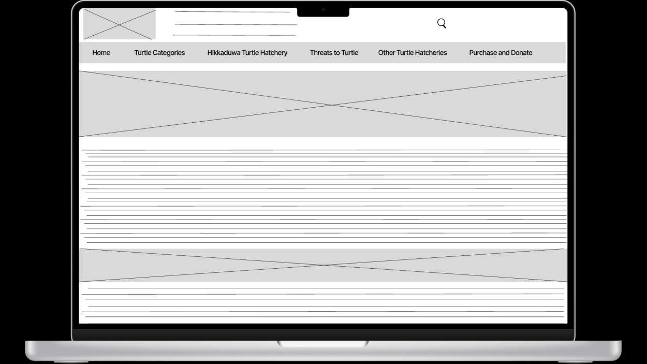

1. Turtle Categories page

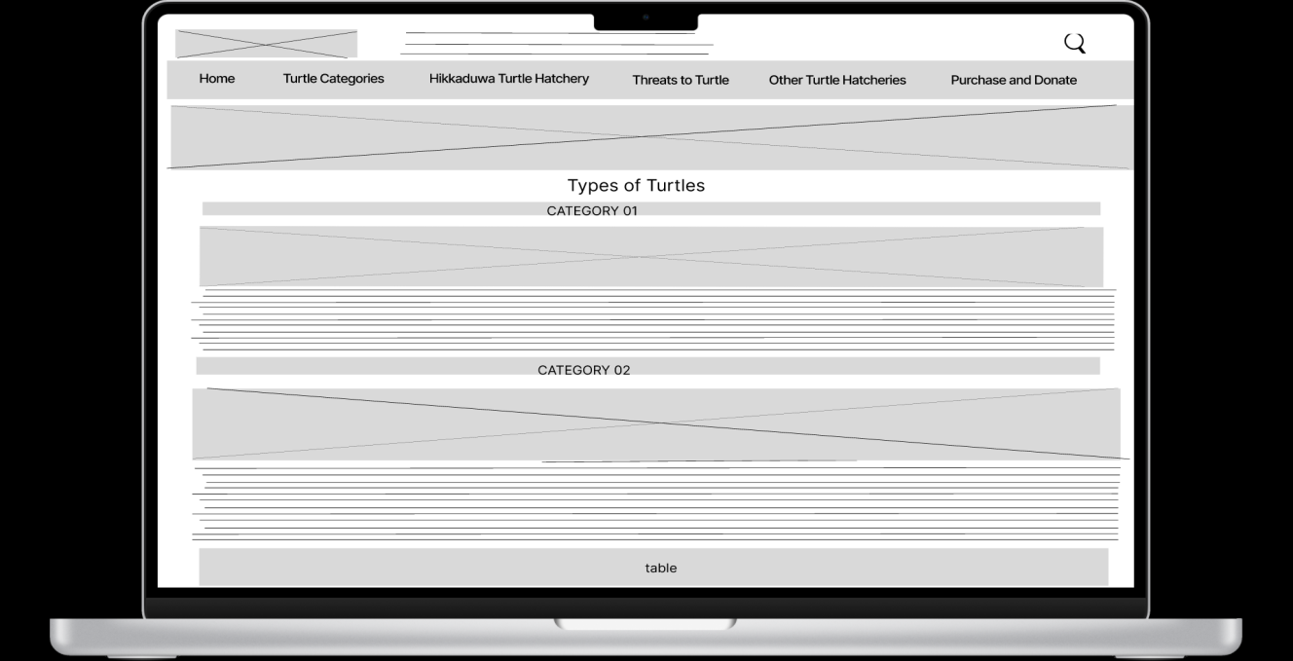

1. Hikkaduwa Turtle Hatchery page 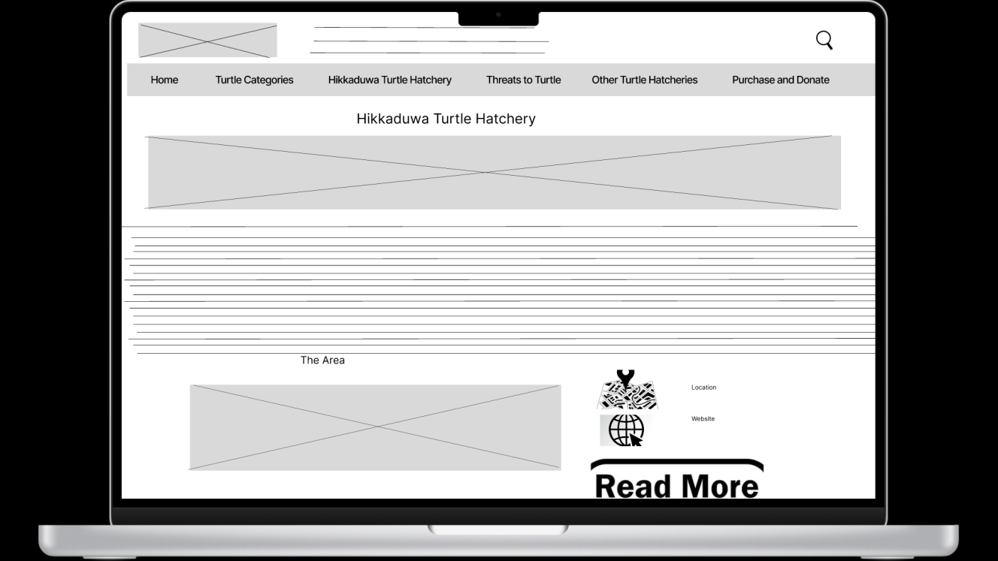
2. Threats to Turtles page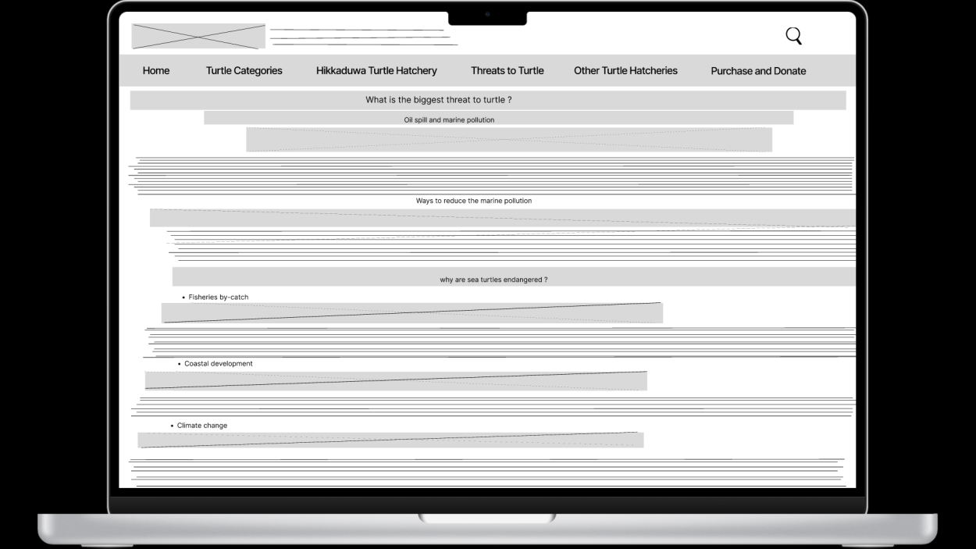
3. Other Turtle Hatcheries page

Kosgoda Turtle Hatchery page

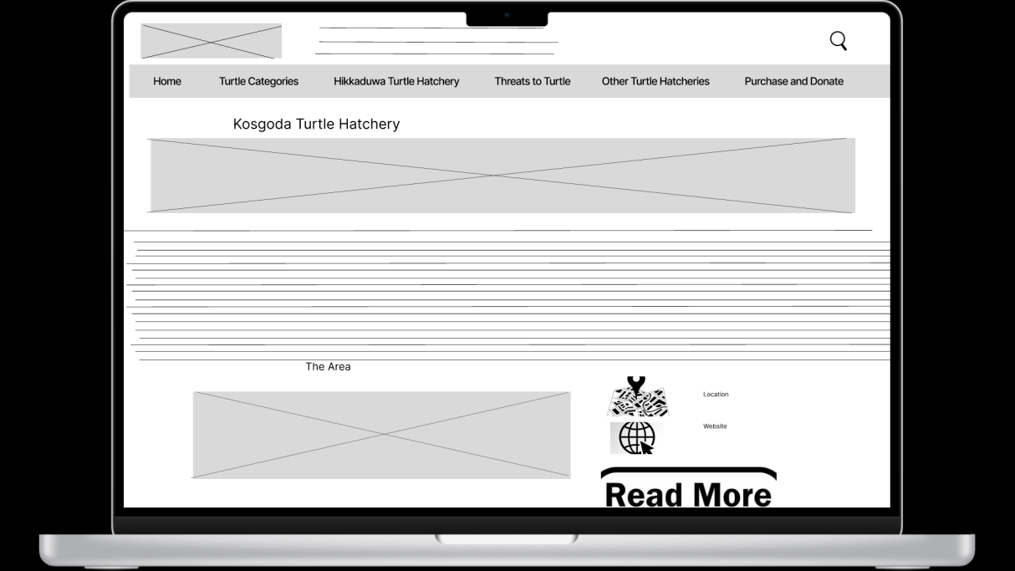

Bentota Turtle Hatchery page

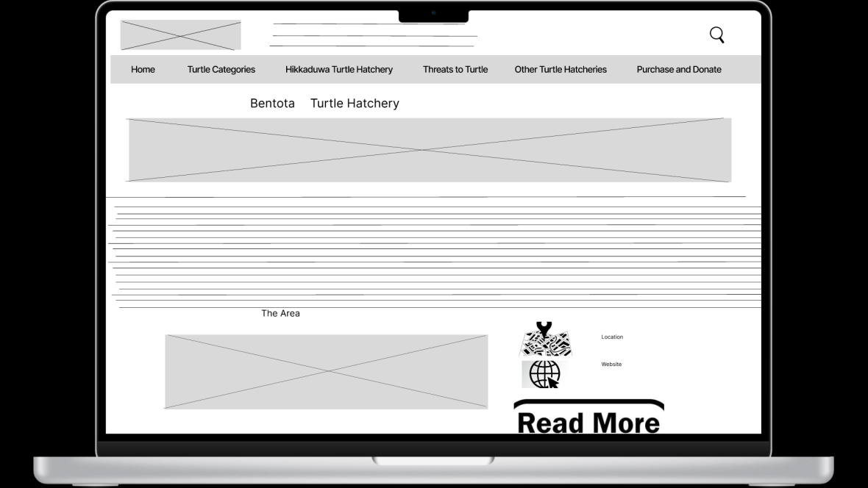

1. Purchase and Donate page

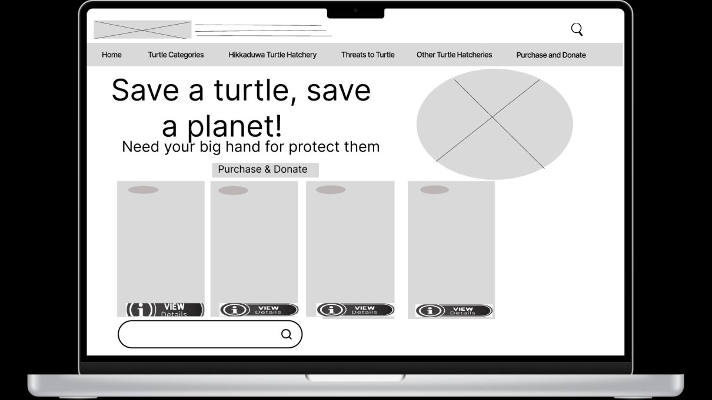

Mobile version wireframes

1. Home page

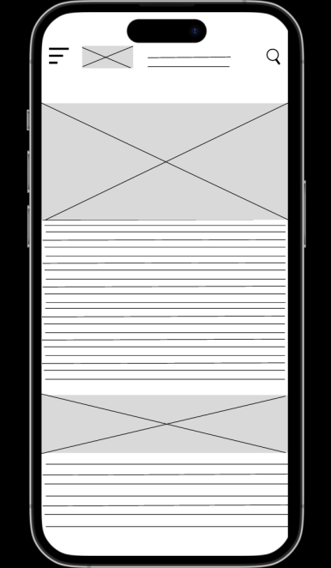

1. Turtle Categories page

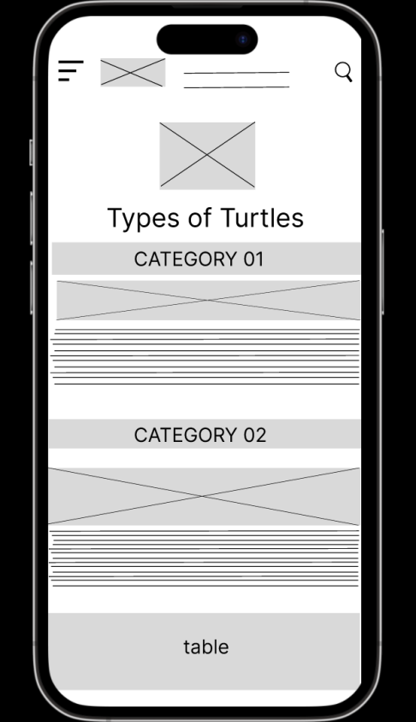

1. Hikkaduwa Turtle Hatchery page

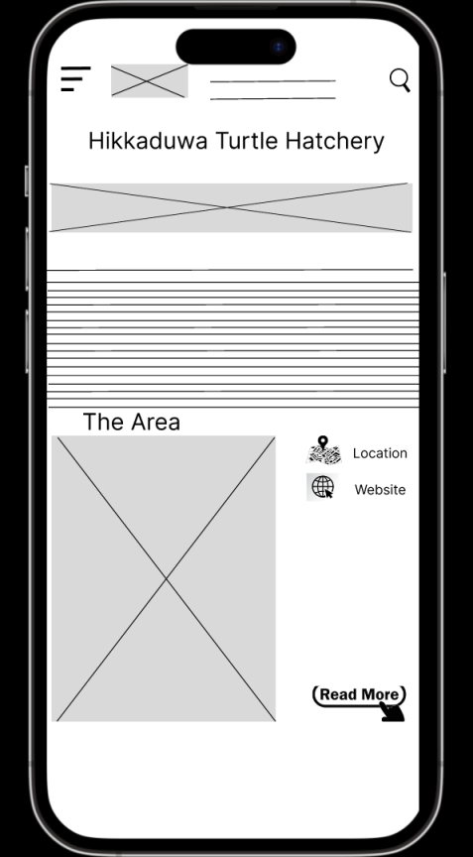

1. Threats to Turtles page

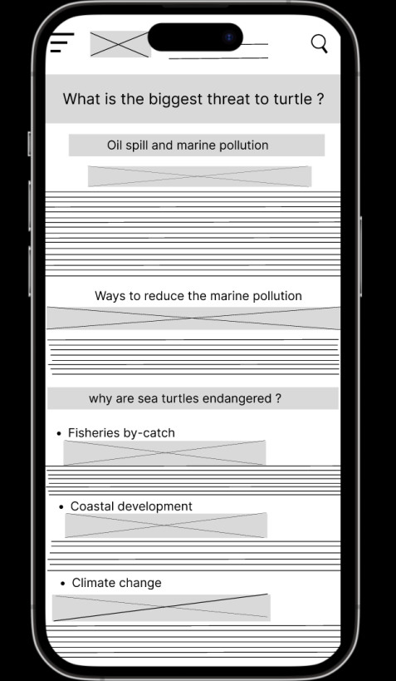

1. Other Turtle Hatcheries page

Kosgoda Turtle Hatchery page

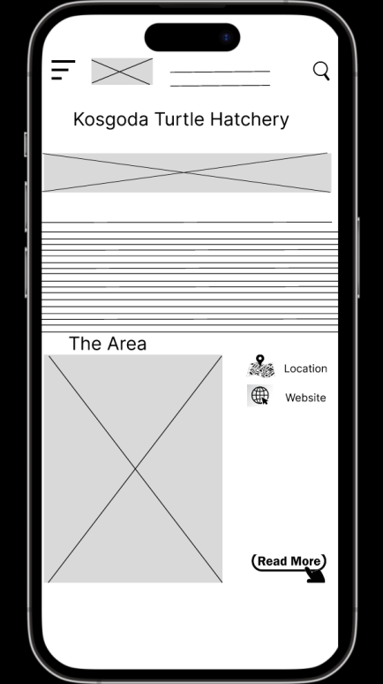

Bentota Turtle Hatchery page

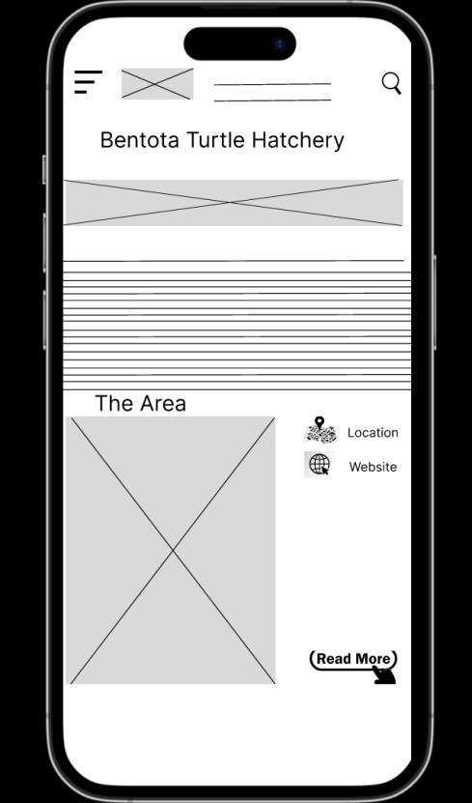

1. Purchase and Donate page

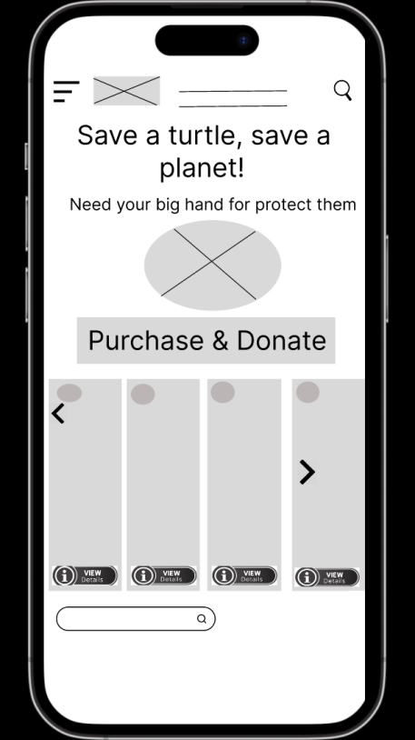

Conclusion

I think this project was successful because I was able to expand my knowledge of html/css cording. I learned how to use html to create my own web site. Html is the universal markup language for the web.